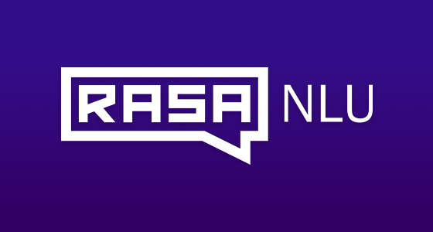

Covid 19 Chatbot Using RASA

Bhavya Parikh

# Introduction

As we know world is suffering from corona virus pandemic so I decided to make **Chatbot** it provides information based on number of cases in state wise and as well as district wise and **FAQ related question** user can ask and Bot can replay answer according to that .

Also we are going to include **data visualization for demographic data visualization of Indian state, Top 10-20 most effected state, pie charts, bar** **plots, etc**.

And all data will be real time so user get updates of cases and information every day.

# Why Rasa NLU

Rasa is essential in creating great AI assistants. Building contextual assistants & Chatbot that really help customers is hard. Rasa provides infrastructure & tools necessary for high-performing, resilient, proprietary contextual assistants that work. With Rasa, all developers can create better text- and voice-based assistants.

Rasa Provide in built Natural Processing Language Understanding so it will be easy to make Chatbot and efficient to use.

It provides different channels to integrate RASA NLU Bot to Telegram, Slack, Facebook Messenger and other platform so user can access it easily.

# How RASA works??

**User going to ask this question. To bot so Rasa NLU will train all this intent and if user will ask about corona virus bot will reply according to text which is as** below

Example:

## **intent**: corona_intro

-I want to know about corona virus

-information on corona virus

-what is corona virus

**utter_corona_intro:**

- text: “Corona viruses are a large family of viruses which may cause, illness in animals or humans. In humans, several coronaviruses are known to cause respiratory infections ranging from the common cold to more severe diseases such as Middle East Respiratory Syndrome (MERS) and Severe Acute Respiratory Syndrome (SARS).The most recently discovered coronavirus causes coronavirus disease COVID-19."

**## What is corona?**

* corona_intro

- utter_corona_intro

So basically it is our story in which it will recognize user input and according to that it will use NLP and determine what to reply in according to message!

I have given the picture where user input and bot replying to that message

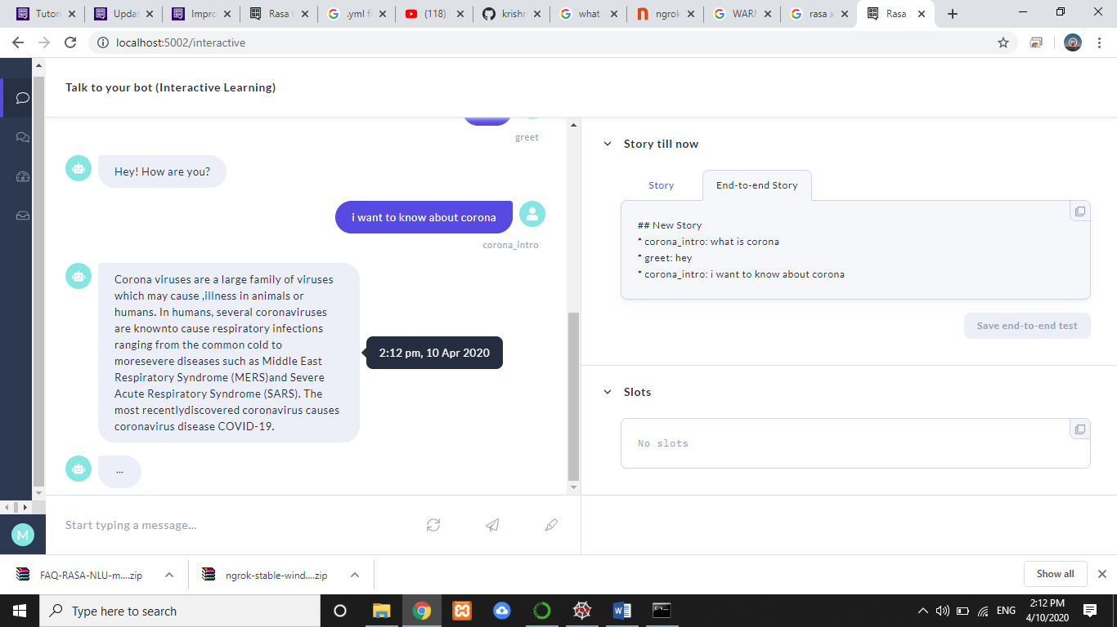

Response from Bot (Image from RASA X which provide UI for conversion with bot)

Domain:

As per the domain if user ask for any information regarding state wise or district wise data bot should reply to these messages so we have used API call which gives us number of cases in any locality by real time data

And here Is an example if user ask for: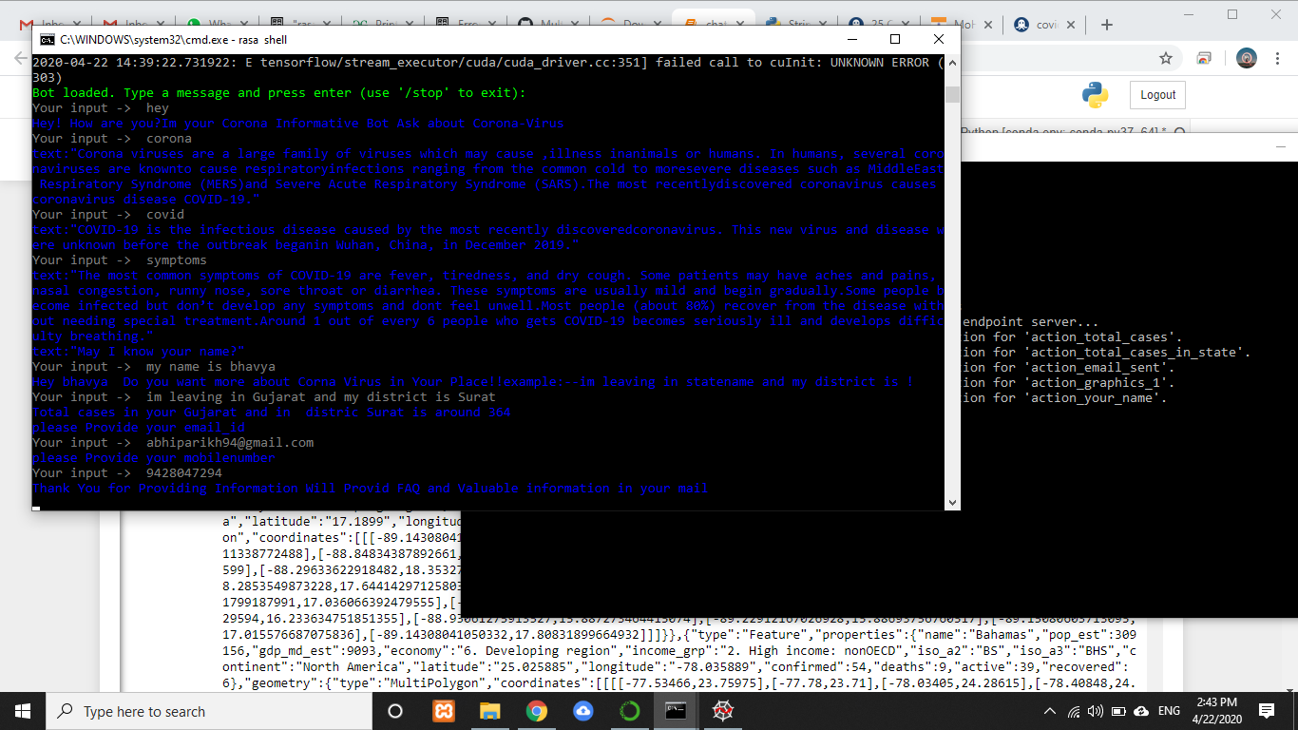

It is Command line conversion with Bot in which it provides with CMD here user has asked for number of cases in locality so user will get response according to that also cross verify

to check the number cases are right or wrong??

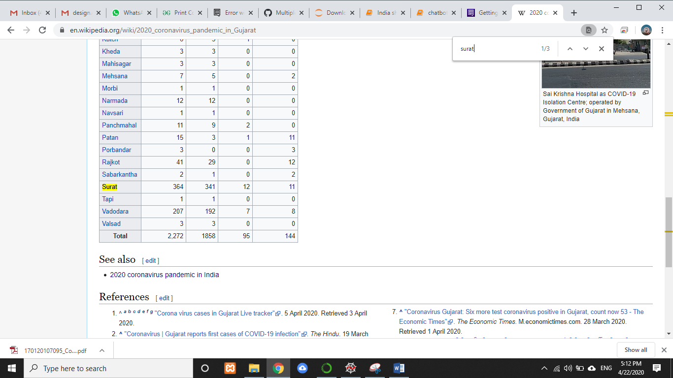

Verify Data

Also after the conversion user will get a email from bot for prevention method which can be helpful during corona virus and FAQ pdf from

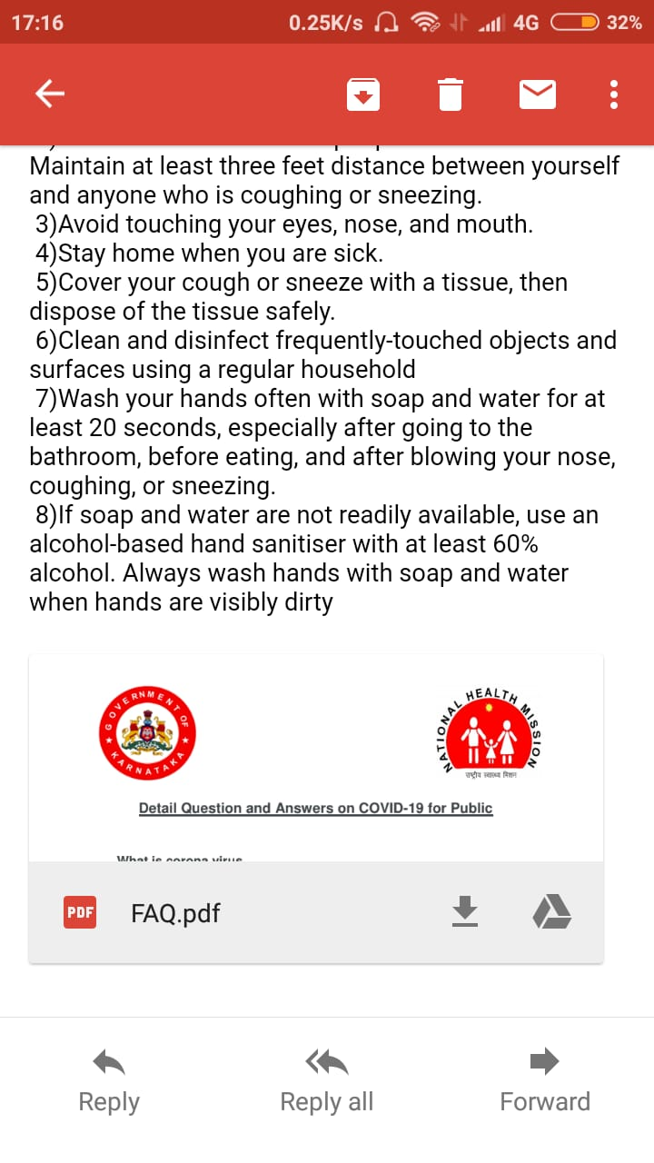

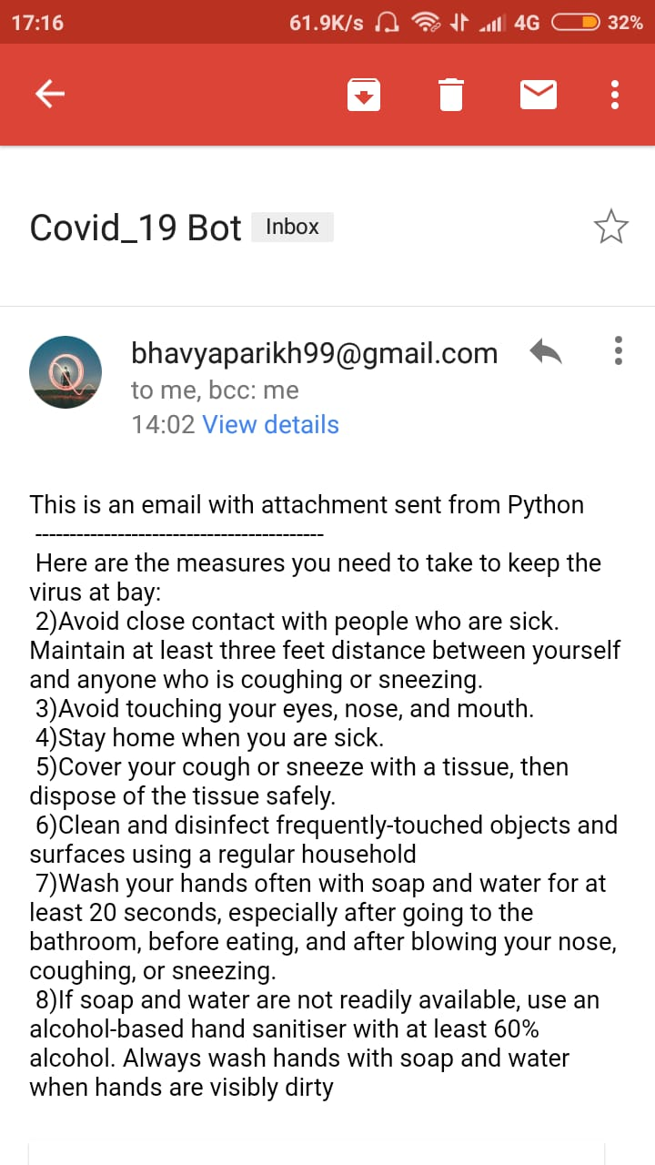

Mail From Bot

Data Visualiztion Part:

If user ask for demographic data of India or world map can be shown to the user, we should able to provide image to them but it is a bit difficult task to do so for that we will use flask framework for that in which every time data visualization will be render and user can get better use of Bot. Data Visualization will be look like this, more charts can be done.

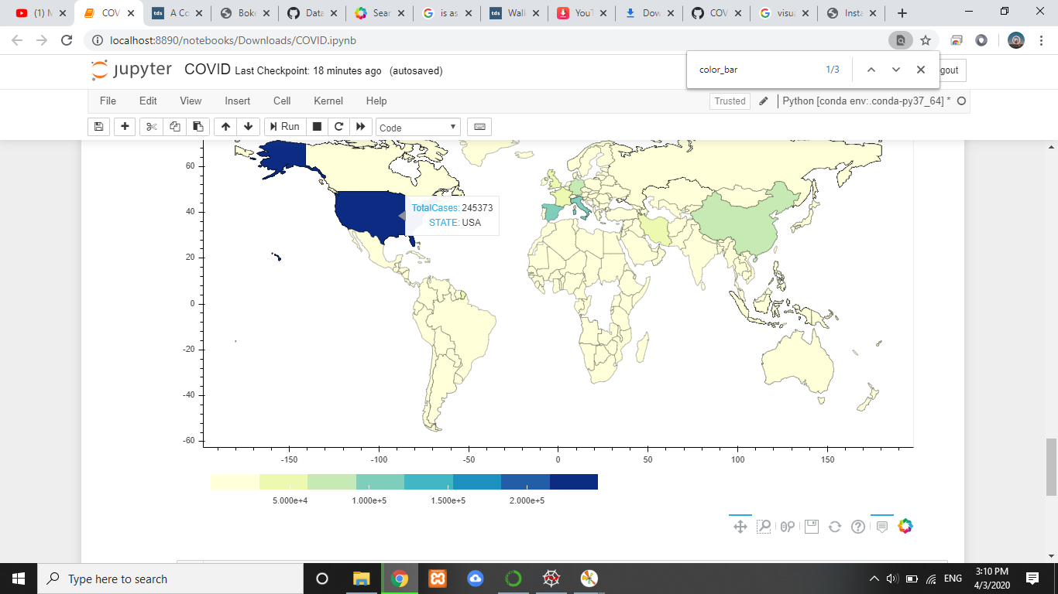

Image of world map for corona (P.S. Image from Dated 3rd April)

Future Work:

We will be going to integrate our bot with Telegram, Slack, Facebook and many more apps which are supported by rasa.

Also more data visualization and make user conversation make flexible get reply in minimum time.